**Purpose:**

This document is to set up API web key using Power BI

**Scope:**

This document applies to all data analysist and epidemiologist using an API web key using Power BI.

**Materials:**

|  |  |
| --- | --- |
| File Name | Location |
| FLUMART/VIW FNT | https:abc123anyweburl.com |
|  |  |

**Prerequisites**:

* Must have Power BI Desktop
* Must have permission to use FluMart public API Key

**Process:**

1. Open Power BI Desktop

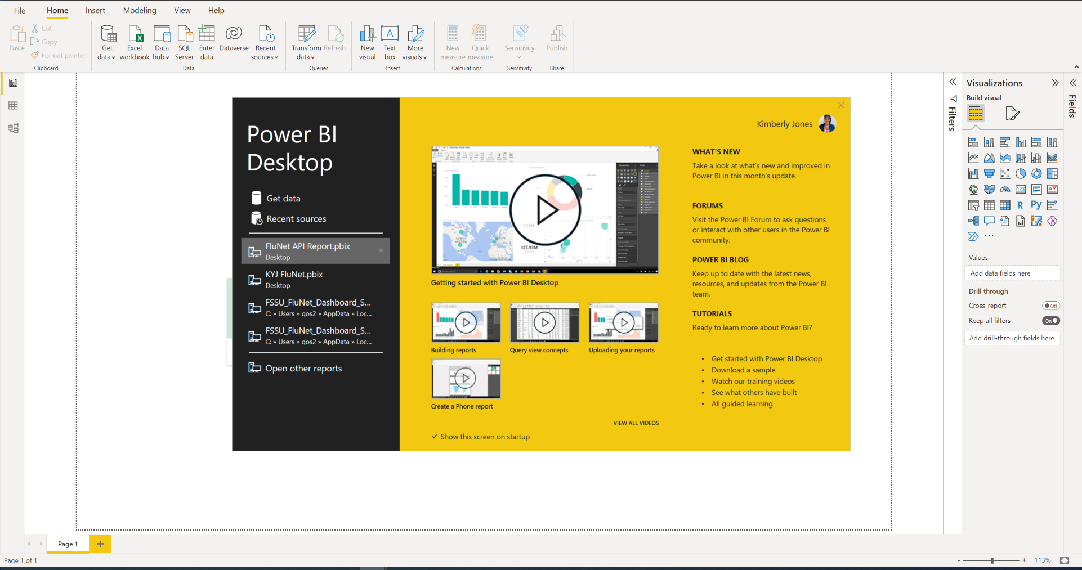

1. Click Get data

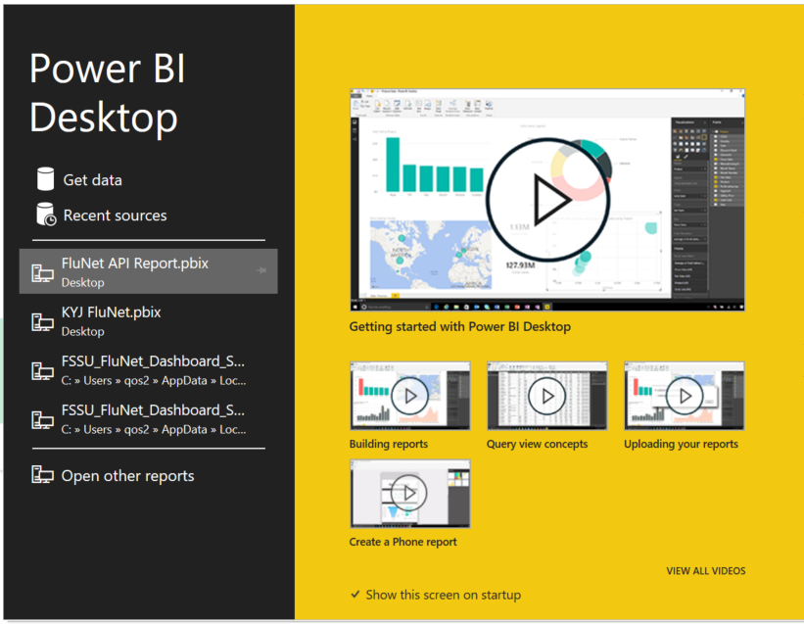

1. Search “web” > Select Web > Click Connect

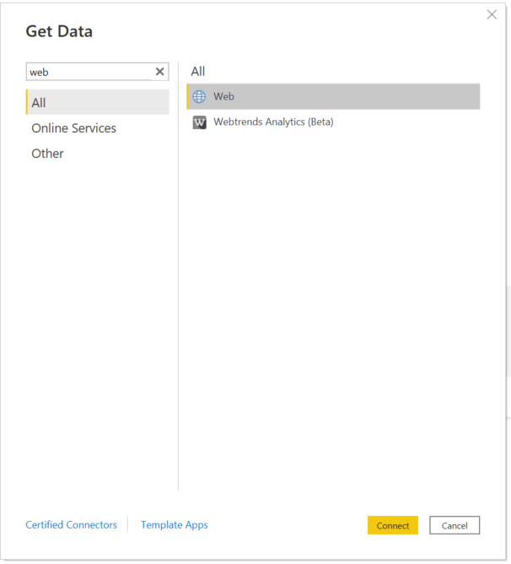

Paste in the url “https:abc123anyweburl.com “

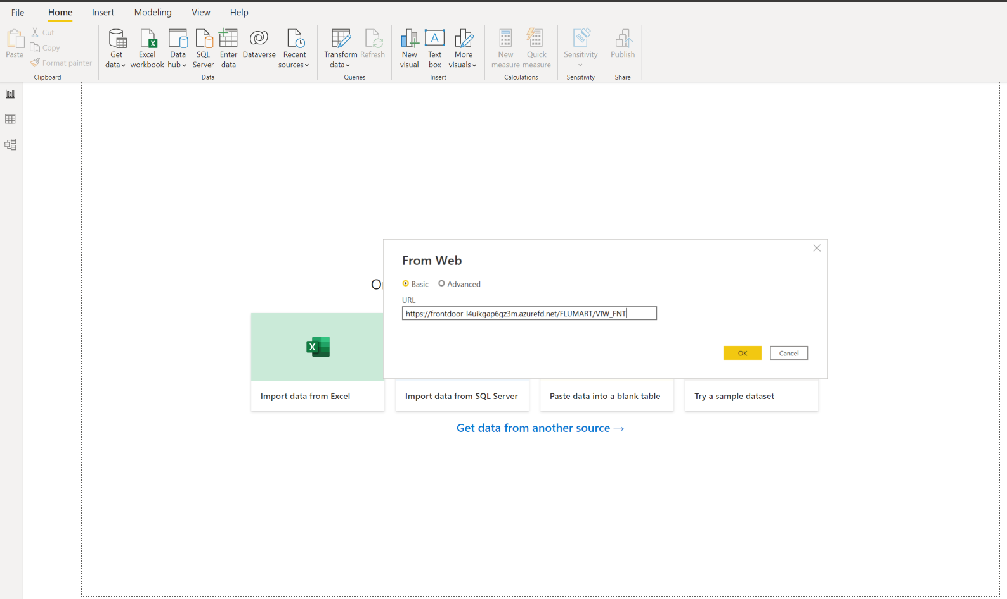

1. You will get a pop-up window letting you know the server is connecting to the url key

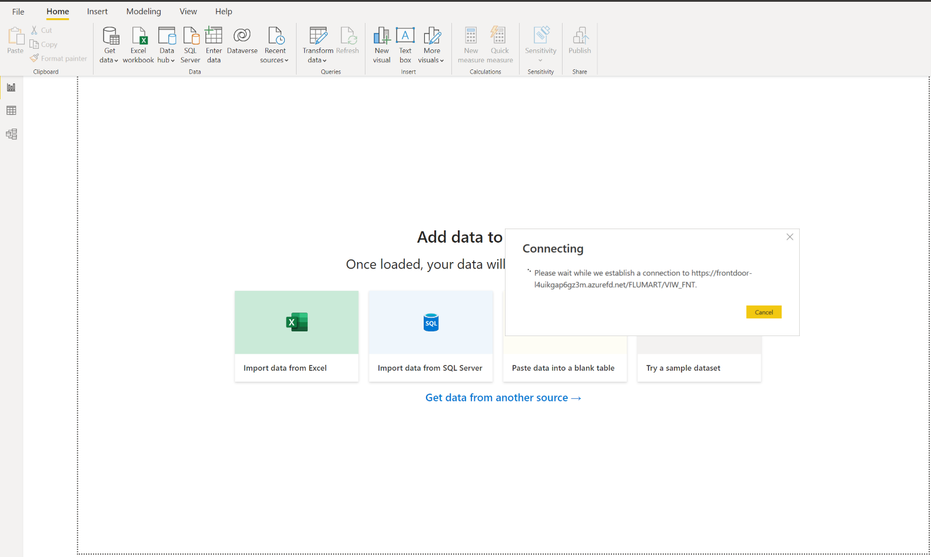

1. Power Query Editor will open to allow for edits

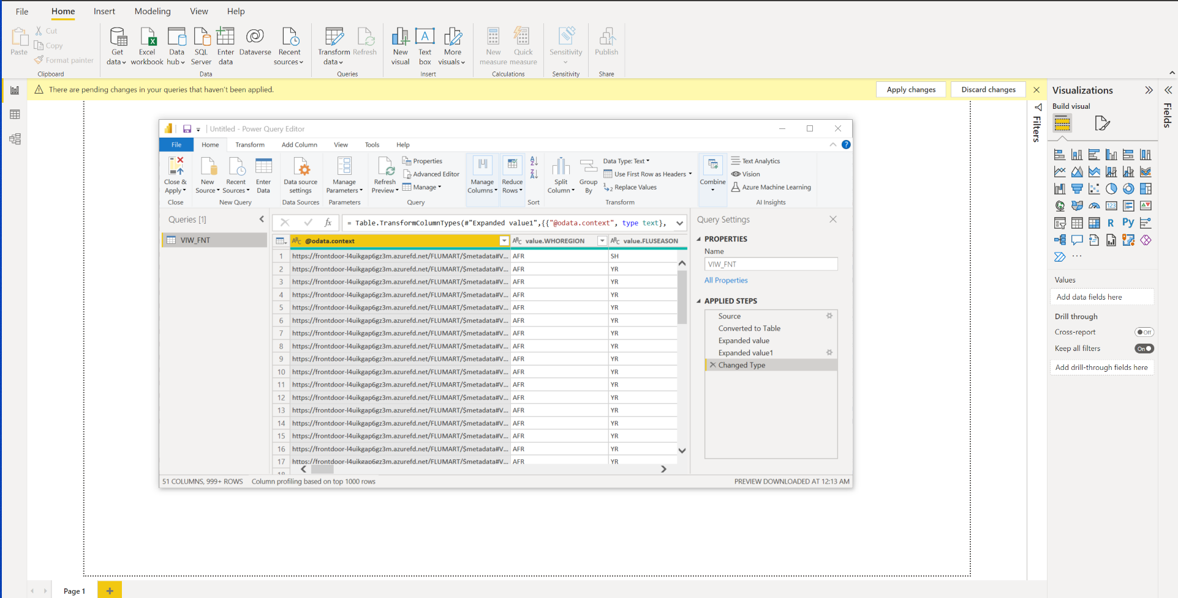

1. As you make changes you will see the changes in the right pane labeled “Applied Steps”
   1. If you have made an error click on the x next to the step to remove and start over
2. Click Close and Apply

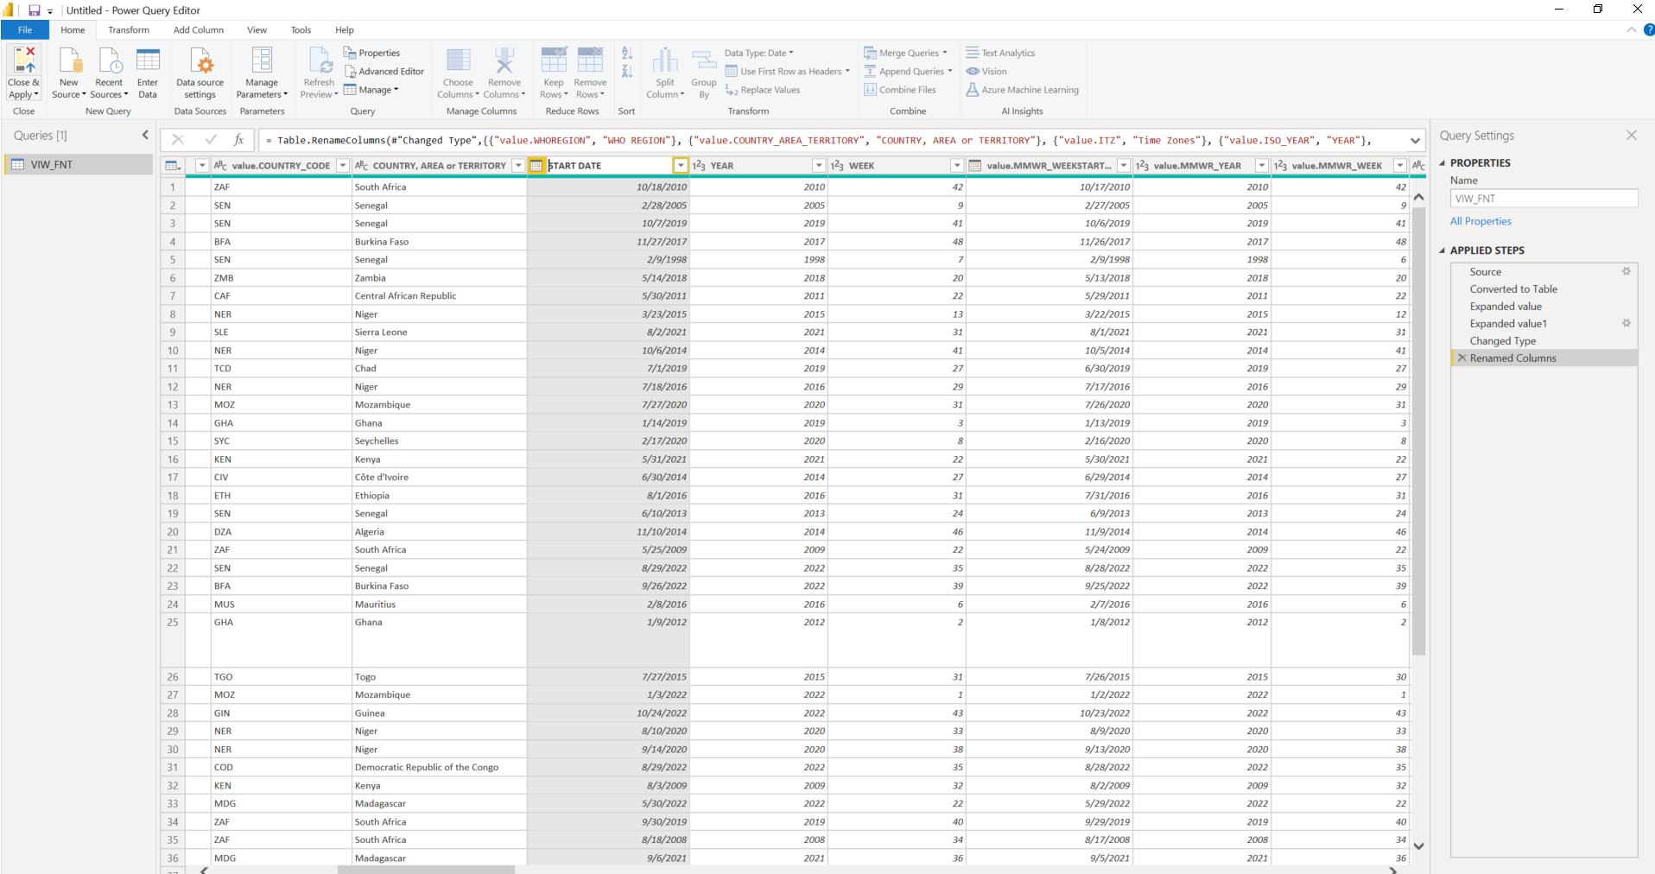

1. Power BI will upload and apply the changes

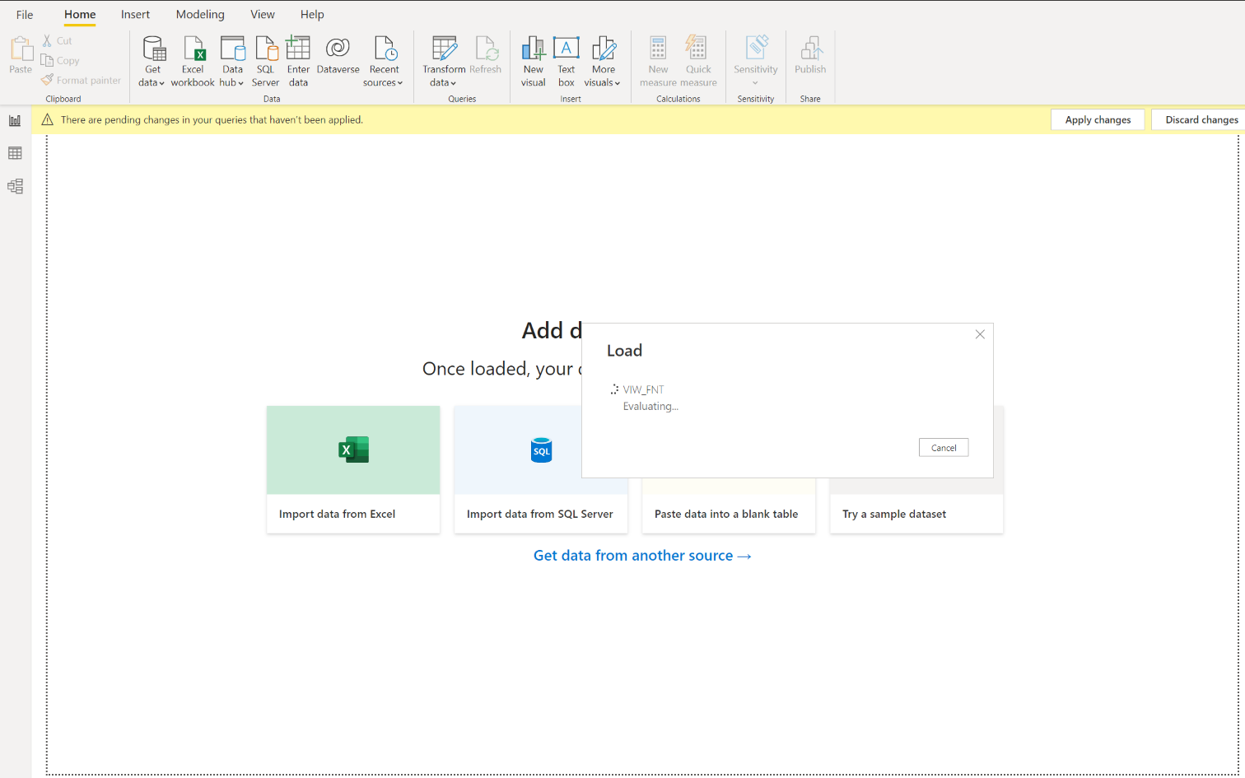

1. Once data is loaded you will get messages of any error while loading
2. Click on “view errors”

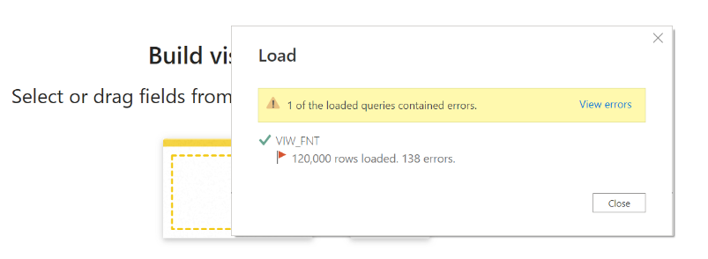

1. Power Query Editor re-opens for you to correct or override the errors
2. Click Close & Apply if there are no changes

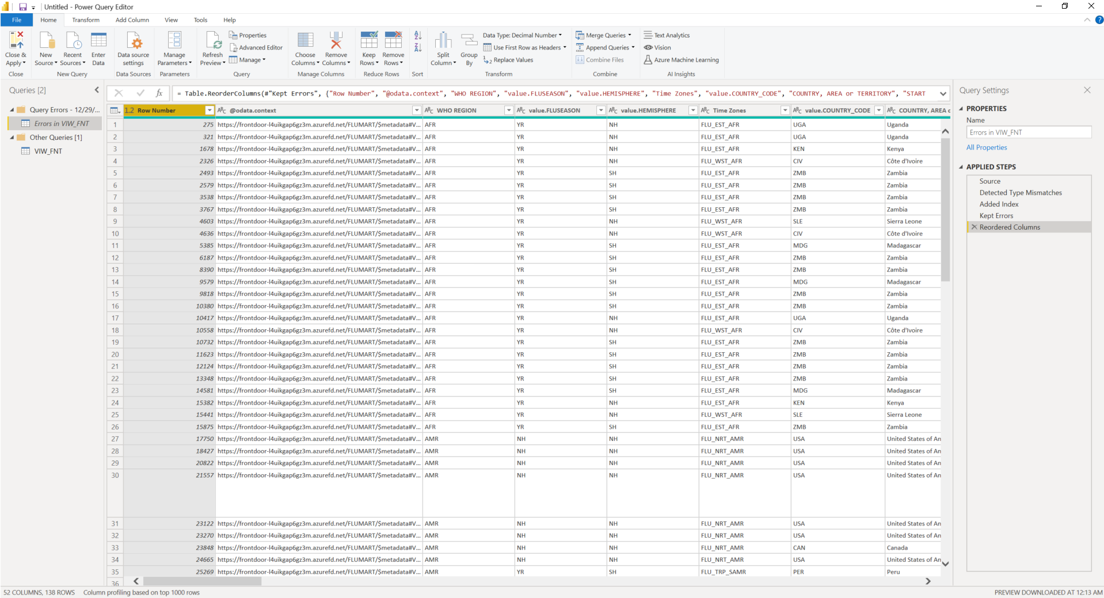

1. Click on the Report icon to the left of the screen
   1. Data will show on the right side of the screen to begin using for your models

